DoS & DDoS Attacks Lab

Introduction
This lab report is part of Module Cybersecurity, focusing on Denial of Service (DoS) and Distributed Denial of Service (DDoS) attacks. The objective of this module is to understand how DoS/DDoS attacks work, their types, commonly used tools, detection techniques, and protection mechanisms. This lab combines theoretical understanding with hands-on exposure to attack simulation tools (used strictly in a controlled lab environment for educational purposes).
This report is prepared based on:
- Self-created notes during the lab sessions
- Module reference notes provided by the institute

Learning Objectives
- Understand the concept of DoS and DDoS attacks
- Differentiate between DoS and DDoS
- Learn about botnets and their role in DDoS attacks
- Study different types of DoS/DDoS attacks
- Gain familiarity with common DoS/DDoS tools
- Learn detection and mitigation techniques

DoS and DDoS Overview

Denial of Service (DoS)
A Denial of Service (DoS) attack is launched from a single source with the intention of making a system, server, or network unavailable to legitimate users by overwhelming it with traffic or requests.

Distributed Denial of Service (DDoS)
A Distributed Denial of Service (DDoS) attack is launched from multiple sources, usually compromised systems (botnets), making it more powerful and harder to detect and mitigate than a DoS attack.

Key Difference:
- DoS → Single attacker/source
- DDoS → Multiple attackers/sources

Botnets
A botnet is a network of compromised devices controlled by an attacker (botmaster). These devices are infected with malware and are used to perform large-scale attacks such as DDoS, spamming, credential theft, and malware distribution.

Characteristics of Botnets
- Large-scale and globally distributed
- Stealthy operation
- Controlled via Command & Control (C2) servers
- Commonly used in DDoS attacks
Example: Mirai Botnet (IoT-based)

Types of DoS/DDoS Attacks
Volumetric Attacks
- Based on brute-force traffic flooding
- Measured in bits per second (bps)
- Targets network bandwidth
Examples:
- UDP Flood
- ICMP Flood
- Ping of Death
- Smurf Attack
- DNS Amplification

Protocol Attacks
- Target Layer 3 (Network) and Layer 4 (Transport) of the OSI model
- Measured in packets per second (pps)
- Harder to detect
Examples:
- SYN Flood
- ACK Flood
- SYN-ACK Flood
- Fragmentation Attacks

Application Layer Attacks
- Target Layer 7 (Application Layer)
- Measured in requests per second (rps)
- Mimic legitimate user behavior
Examples:
- HTTP GET/POST Flood
- Slowloris Attack
- UDP Application Layer Flood
- DDoS Extortion Attacks

DoS/DDoS Attack Tools (Lab Study)
⚠️ Note: The following tools were studied and tested only in a controlled lab environment for educational purposes.

Tools Covered:
- GoldenEye – HTTP Flooding Tool
- Slowloris – Low bandwidth application-layer attack
- Raven-Storm – Multi-purpose DoS framework
- Metasploit Auxiliary (SYN Flood)
- OWASP HTTP POST Tool
- XOIC – Packet flooding tool
- TorsHammer – Tor-based slow POST attack
- THC-SSL-DoS – SSL exhaustion attack tool
- HTTP DoS Tool (GUI-based)
- HOIC (High Orbit Ion Cannon)
- LOIC (Low Orbit Ion Cannon)
- Hping3 – Packet crafting and flooding tool

- Controlled Lab

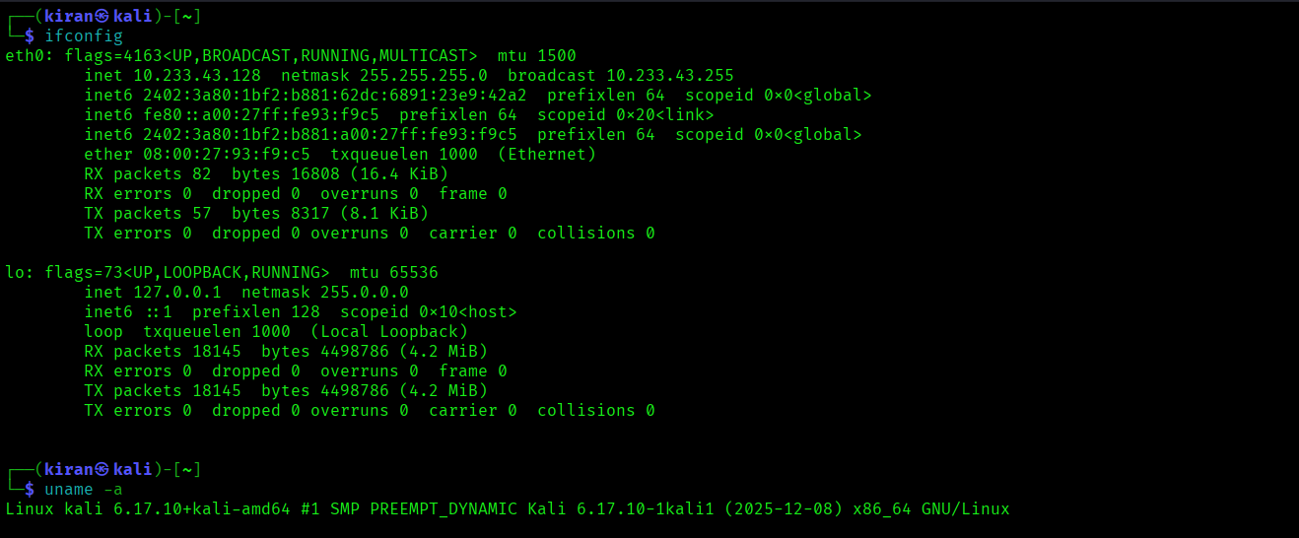

⚠️ This lab is conducted for educational purposes only...
- goldeneye

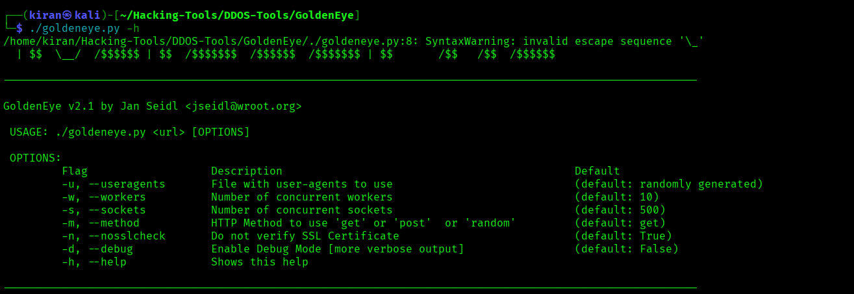

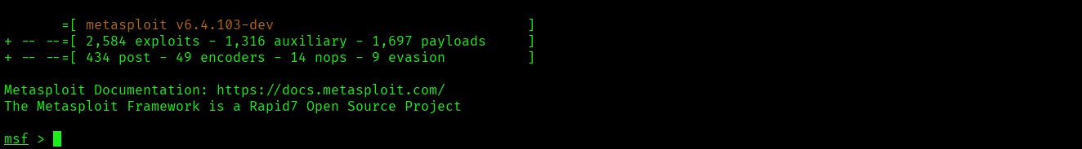
- Metasploit

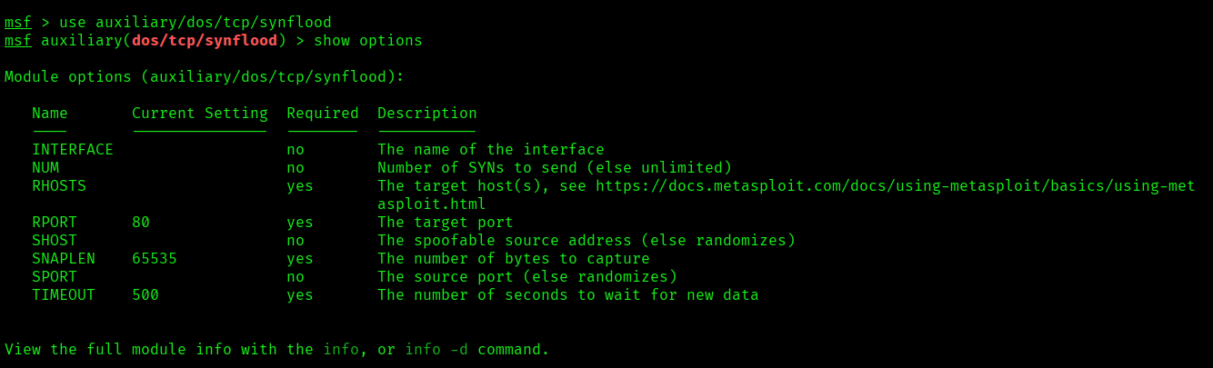

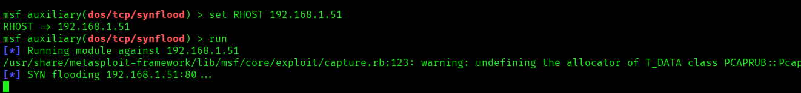

Hping3

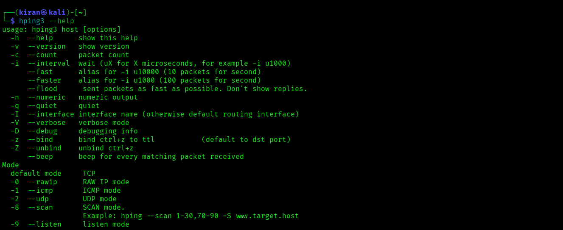



slowloris
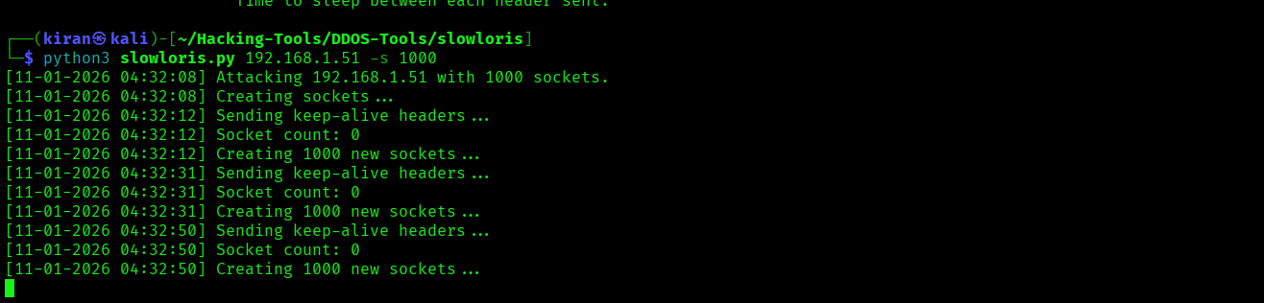

Network Traffic analysis during DoS attack lab using Wireshark
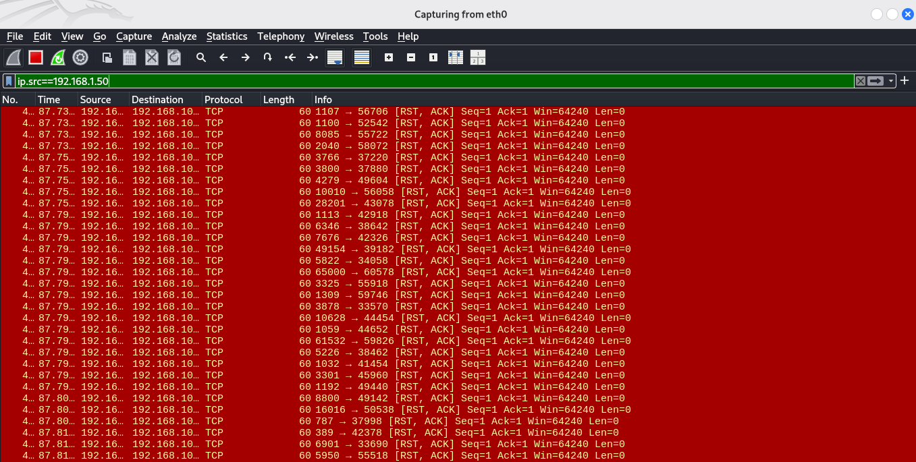

DoS/DDoS Detection Techniques

Common Detection Methods:
- Traffic Volume Analysis
- Rate-based Detection (RPS, PPS)
- Behavioral Analysis
- Signature-based Detection
- Anomaly-based Detection
- Source-based Detection
- Protocol Analysis
- Flow-based Detection (NetFlow, sFlow)
- Entropy-based Detection
- Machine Learning-based Detection

Detection Tools:
- Snort / Suricata (IDS)
- Wireshark
- SIEM Solutions
- Cloud-based Anti-DDoS Services

DoS/DDoS Protection and Mitigation

Prevention Techniques:
- Firewalls and Intrusion Prevention Systems (IPS)
- Rate Limiting
- Load Balancing
- Content Delivery Networks (CDN)
- Anti-DDoS Services (Cloudflare, AWS Shield)
- Secure Network Architecture

Mitigation Strategies:
- Blackholing / Sinkholing
- Traffic Filtering
- Blocking Malicious IPs
- Incident Response Planning

Impact of DoS/DDoS Attacks
- Service Downtime
- Financial Loss
- Reputational Damage
- Increased Operational Costs
- Legal and Compliance Risks

Author
Name : Kiran Karenavar
Course : Cybersecurity / Ethical Hacking
Module : DoS / DDoS | Ethical Hacking Lab

Conclusion
This Module provided a comprehensive understanding of DoS and DDoS attacks, including their types, tools, detection mechanisms, and mitigation strategies. Hands-on exposure to various attack tools enhanced practical knowledge while emphasizing the importance of ethical and responsible cybersecurity practices. Understanding these attacks is crucial for building resilient and secure systems in real-world environments.

